Project
What this project is trying to obtain
Your project is not mainly trying to build a normal website.
It is trying to build a privacy-preserving bot and anomaly detection system for website traffic.
That means the project wants to obtain:
- Safe website telemetry
Data about website activity without collecting unnecessary private information.
- A labelled dataset
Examples of human traffic, good bots, bad bots, scanners, and fake analytics traffic.
- Detection features
Useful columns such as request rate, User-Agent type, favicon behavior, error rate, robots.txt request, and optional TLS features.
- A working detection model
A model that can classify or score traffic as normal, suspicious, or bot-like.
- A serverless/edge prototype
A Cloudflare Worker or similar serverless layer that collects or filters traffic.
- Privacy proof
A clear explanation that the system avoids raw IPs, passwords, cookies, tokens, and unnecessary personal data.
Your proposal expects a bot/anomaly detection layer, serverless deployment idea, ML detection, measurable precision/recall, and privacy controls.
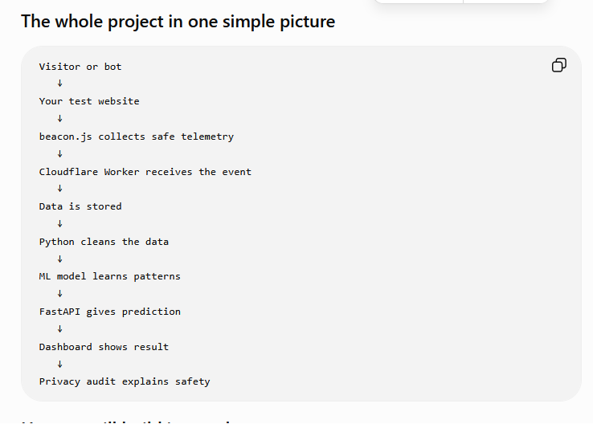
Step | What we do | What you will understand
1 | Create project folder | Where everything lives
2 | Create simple website | What traffic will visit
3 | Add beacon.js | How website activity is collected
4 | Create Cloudflare account | Where website/serverless part runs
5 | Deploy website to Cloudflare Pages | How website goes online
6 | Create Cloudflare Worker | How serverless collector works
7 | Send beacon data to Worker | How frontend talks to backend
8 | Store data | How telemetry becomes logs
9 | Create synthetic bot/human traffic | How we get labelled examples
10 | Build dataset | How raw logs become ML data
11 | Feature engineering | How we create useful detection columns
12 | Train ML model | How model learns bot patterns
13 | Create FastAPI prediction API | How model becomes usable
14 | Make dashboard | How results are shown
15 | Add TLS mini-lab | How TLS fingerprinting fits
16 | Privacy checklist | How project stays privacy-preserving

Option 1: Build a simple test website ourselves
This is the best option for your project.
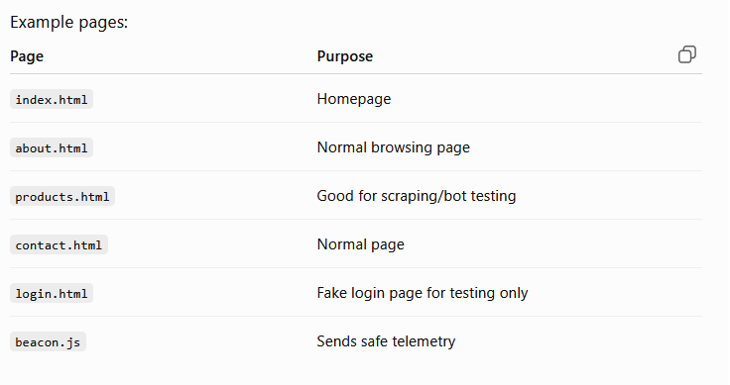
Option 2: Use a website template
We can download or create a simple HTML template, then modify it.
This is faster, but for learning, I recommend we first create a very simple website ourselves so you understand every file.
Option 3: Use Cloudflare Pages starter
Cloudflare Pages can host your website after we create the files. But Cloudflare does not magically create your whole project. It gives you a place to upload/deploy the website.

Term | Meaning
Cipher suite count | How many encryption options the client offers
Extension count | How many extra TLS details are sent
ALPN | Which web protocol is chosen, like HTTP/2 or HTTP/1.1
SNI | Website name the client wants to connect to
JA4 | TLS fingerprint based on handshake behavior

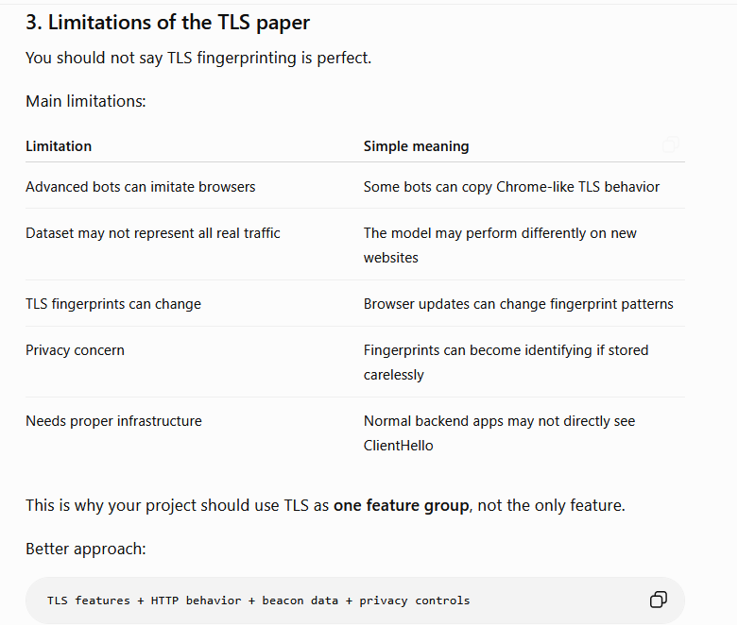
The TLS paper shows that TLS handshake metadata can help identify bad bots because it reflects how a client actually connects to a website, rather than only what it claims in the User-Agent string. Our project applies this idea by including TLS-inspired features such as cipher suite count, extension count, ALPN, SNI presence, and optional JA4 fingerprinting as part of a broader privacy-preserving bot detection pipeline.
